STOCKLOT OVENWARE AND TABLEWARE
O/ Ref.Nr. | Description |  |  |  | Measures |  |  |  |  | TOTAL WEIGHT | TOTAL | TOTAL PIECES | TOTAL PIECES
Nr. Pallets | Photo | Item | Brand | Colour | Length  (cm) | Width  (cm) | Diameter  (cm) | Height  (cm) | Weight  (Kg) | per pallet | WEIGHT | per pallet
1 | 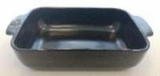 | Baking tray | PEUGEOT | BLACK | 24,00 | 15,00 | N/A | 6,00 | 0,892 | 492,38 | 492,38 | 552 | 552
8 | 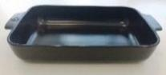 | Baking tray | PEUGEOT | BLACK | 36,00 | 22,00 | N/A | 7,00 | 2,038 | 407,60 | 3260,80 | 200 | 1600
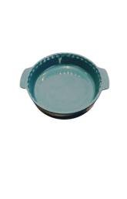  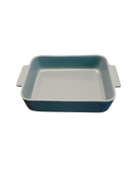  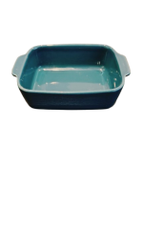  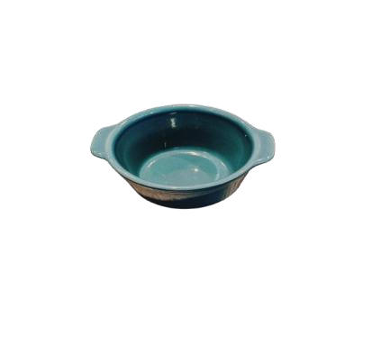  5 | 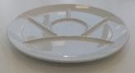 | Gourmet Plate | VIVO | WHITE | N/A | N/A | 27,00 | 2,00 | 0,780 | 312,00 | 1560,00 | 400 | 2000
1 |  | Baking tray | ROYAL VKB | BLUE | 30,00 | 21,00 | N/A | 6,00 | 1,845 | 442,73 | 442,73 | 240 | 240
1 |  | Baking tray | MEDART NOBLAT | BLUE | 24,00 | 15,00 | N/A | 5,00 | 0,923 | 479,91 | 479,91 | 520 | 520
1 |  | Baking tray | MEDART NOBLAT | BLUE | 28,00 | 24,00 | N/A | 10,00 | 2,038 | 407,60 | 407,60 | 200 | 200
1 |  | Bowl | MEDART NOBLAT | BLUE | N/A | N/A | 10,00 | 6,00 | 0,262 | 628,32 | 628,32 | 2400 | 2400
1 |  | Pan pie | MEDART NOBLAT | BLUE | N/A | N/A | 25,00 | 5,00 | 1,344 | 451,65 | 451,65 | 336 | 336
1 | 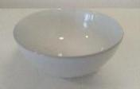 | BOWL | AKTIVA LINE | WHITE | N/A | N/A | 10,00 | 5,00 | 0,229 | 595,40 | 595,40 | 2600 | 2600
1 | 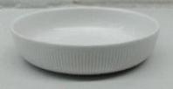 | PASTA PLATE | AKTIVA LINE | WHITE |  |  | 20,00 | 5,00 | 0,610 | 244,00 | 244,00 | 400 | 400

1 | 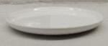 | DESSERT PLATE | AKTIVA LINE | WHITE |  |  | 22,00 | 2,00 | 0,510 | 244,80 | 244,80 | 480 | 480
2 | 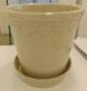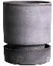 | POTS |  | WHITE/ CREAM/ BLUE |  |  | SEVERAL |  |  | 550,00 | 1100,00 | 600 | 1200
 |  |  |  |  |  |  |  | NR. PIECES |  |  |  | 12 528
24 |  |  |  |  |  |  |  |  |  |  |  | 9907,59
 |  |  |  |  |  |  |  | TOTAL WEIGHT (Kg)

